The Greatest and His Leadership
Jerrell M. Nixon
COM 510: Communication Leadership
Spring Arbor University
Dr. Robert Woods, Jr.
December 4th, 2021

Introduction
When you think of Muhammad Ali, the sport of boxing immediately floods your mind if you are a sports fan. He is still referred as “The Greatest” because of his capabilities, world championships, and success inside the squared circle. However, if you viewed archived footage in documentaries or on social media platforms like YouTube, he firmly believed he was confident in his ability to outsmart, outclass, and outbox his opponents anywhere and anytime. His confidence did not stop inside the boxing right as he also took part in social activism as an additional voice to combat racism during the segregation period inside the United States and his refusal to fight in the Vietnam War. My perception of his rebellious actions was to use his celebrity status as a world-famous boxer to bring awareness to the social injustices being inflicted domestically and abroad. In the boxing ring, physical punishment is the name of the game to wear your opponent with a series of punches – jabs, hooks, uppercuts, and crosses, but Ali managed to challenge the government and media with the same approach in a verbal manner.
His passion for boxing and social activism would be transformational because, according to Hackman and Johnson (2013), “Transformational leaders are passionately committed to their work” and ‘Transformational leaders are able to encourage others because they, first and foremost, encourage themselves” (p. 121). Perhaps he was encouraged by Jackie Robinson, who broke the color barrier in Major League Baseball on April 15, 1947, in his first game with the Brooklyn Dodgers (History.com, 2009). It is possible he was encouraged by Bill Russell, who “was the one pulling himself out of an NBA game as a demonstration against racist behavior” (Bieler, 2020) in 1961. Presently, formerly NFL Quarterback Colin Kaepernick has been blackballed from the league due to taking a knee in protest of police brutality towards black people. Similarly, “Kaepernick is thoughtful and articulate” and “has been able to clearly state his beliefs and purposes in his protest” (Bryant Jr., 2020) thanks to Muhammad Ali. Linking historical leadership and contemporary leadership should continue to inspire future generations to dismantle oppression and unnecessary violence and with a social platform, that message can be echoed further so society can live comfortably in our faith, skin, and communities by unanimous decision.
Leadership Behavior
Out of the five primary approaches discussed by Hackman & Johnson (2013), the approach that best fit Muhammad Ali’s character outside of the boxing ring is the functional approach. The functional approach looks at the way leaders behave (Hackman & Johnson, p. 72), in this case, he disagreed with how the federal government’s handling of his decision to reject his involvement in the Vietnam War. Maher (2016) provided the champ’s quote of his reason of refusal: “No, I’m not going 10,000 miles from home to help murder and burn another poor nation simply to continue the domination of white slave masters of the darker people the over. This is the day when such evils must come to an end. I have been warned that to take such a stand would cost me millions of dollars. But I have said it once and I will say it again. The real enemy of my people is here. I will not disgrace my religion, my people, or myself by becoming a tool to enslave those who are fighting for their own justice, freedom, and equality” (paras 3-6). As a black public figure, my perception of his logic is his life was and have been at steak for years by being a black man in America and he was not going to allow a segregated country like America to control his beliefs. His reputation and career were at risk, but Ali knew that social issues during that time were bigger than boxing and he utilized his platform to remain firm on his Muslim beliefs and combat the domestic war known as racism.
The integrity of a black boxing world champion of his caliber demonstrated how aware and conscious Ali was citing his social appraisal, defined by H & J as “the ability to recognize the feelings and behaviors of others in social situations and to respond effectively based on that knowledge” (p. 75). It is one objective to talk trash to an opponent to gain a psychological advantage (which he has done), but it is another objective to publicly address the issues within a predominantly white nation that only loved his athleticism for entertainment. An example like this is the Laura Ingraham insensitive comment towards LeBron James by stating “Keep the political comments to yourselves…shut up and dribble” (Sullivan, 2018) in response to James’s criticism of then-President Donald Trump. Leadership is about who you are, how you act, what you do, and how you work with others (Hackman & Johnson, p. 10) and the past and present footage of how black American athletes conduct themselves regarding social justice issues is cemented in American history to change the world. In the film, “Muhammad Ali: A Film by Ken Burns, Sarah Burns & David McMahon (2021), Ali stated “My people are for me, they identify with my struggle, same one they’re fighting every day in the streets and against the police. If I win, they win, if I lose, they lose” (30:39-30:52).
That quote references himself being a folk hero of black Americans but at the same time being the “People’s Champion” for draft evasion resulting in being stripped of his world boxing championship and facing prison time. Regardless of any type of leadership, there is no perfect leader nor leadership style because it varies from person to person and Ali is not excluded here. With rewards come costs as journalist Robert Lipsyte states in the film, “And the reason he won America was that he was now very clear how much he had sacrificed” (46:00-46:08) and my interpretation of that is Ali has gained a large support system for his religious and activism beliefs, but he was “also the product of poor decision making” when he regained his boxing license believing he was the same fighter that gained him social status. Even leaders must recognize they are wrong, but Ali did not until it was too late to salvage relationships and his declining health.
Religious Faith
My definition of faith is believing in an entity greater than myself who provides the undiscovered inner strength of any kind to achieve goals during the adventure of life while upholding the words and work of that entity on earth. I was raised to be a Christian and have maintained that status today, but that does not mean that a specific religion is fit for everyone as everyone searches for items that are best for them. Here, “Cassius Clay Sr., was a Methodist, but he allowed his wife, Odessa O’Grady Clay, a devout Christian, raised their sons Cassius Jr. (Ali) and Rudolph “Rudy,” as Baptist” (Morgan, para 3). Discovering this information from the Morgan piece has me self-reflecting on my Christian (Baptist) practice due to my upbringing in Christian faith and forwarding this practice to my children and my wife was baptized as a Catholic as a child. The parallel between my family and the Clay family is that we acknowledge and serve God regardless of background because it is the righteousness we demonstrate as leaders of the household to ourselves and those who look up to us. Matthew 20:26 states “Yet it shall not be so among you; but whoever desires to become great among you, let him be your servant” (The Holy Bible, p. 866).
You may have heard an old saying that “we were born to die” that has been “thrown around” society, but my perspective is we were born to serve in preparation to lead others and still serve the Almighty. when Cassius Jr. changed his name to Cassius X, the leader of the Nation of Islam (NOI), Elijah Muhammad, gave him the name Muhammad Ali (Morgan, para 7). People’s ideologies change with time, including religion, but my theory is with growth comes discovery in spiritual evolution from what was your leaders (parents) to a new directive. Followers then work under the guidance of the leader who encourages and rewards initiative and provides the necessary resources and training (Hackman & Johnson, pp. 158-159), therefore Ali self-discovered the NOI and “attended his first meeting in 1961”, was introduced to Malcolm X, and “Malcolm was ringside when Ali defeated Sonny Liston in 1964 to become the world heavyweight champion” (Morgan, para 5). He reintroduced himself as a servant to the Islamic faith and led himself to that transition from the Christian faith, however he still acknowledged there was a higher power. Morgan (2016) includes a quote from Ali stating, “I’ve changed my religion and some of my beliefs since them, but her God is still God; I just call him by a different name” (para 4). The issue of Ali, in my worldview, regarding his faith is he did not take it as serious as his boxing career. The reason being, besides his notoriety in the media, is “he had been cheating on Belinda frequently. No matter where he went, women sought his attention and affection and members of his entourage helped feed his increasing appetite for casual sex” (Burns & Burns, 12:00-12:11). The Bible denounces adultery in multiple books and verses, although the Islamic faith practice from the Quran, but he himself said God is still God but in a different name. The act of adultery is sinful to himself, Belinda, their marriage, their children, and his faith which resulted in a pitfall he could not avoid, specifically the “Signs of Overconfidence” being “overly optimistic and prone to take extraordinary risks” (Hackman & Johnson, p. 214). Marriage is honorable among all, and the bed undefiled; but fornicators and adulterers God will judge (The Holy Bible, p. 1061). Perfect only exists in the perfect world, but it is fair to state that the superstar persona clouded Ali’s judgement of being faithful to his religion and family which became detrimental personally by living the double life of a family man and star.
Conclusion
It is mentioned from 50:49-53:30 in the Burns & Burns film that Ali burned through seven million dollars not only for caring for himself and family, but he would also perform acts of kindness to strangers by providing them with money and material items. His daughter Rashida states, “he did it all the time” and “because daddy’s purpose was just to help people feel special and help people”. His (former) wife Belinda also states during this time frame “I think he’ll go to paradise because of that, because he did give a lot of charity!” What this explains is someone who chose a violent sport as a career had compassion for the less fortunate and the desire to brighten the world one person at a time. Ali was doing philanthropic work while not acknowledging the title of a philanthropist and the older he became, the more he must have realized that materialistic items could be replace unlike human life that sparked his draft evasion. His successful career gave him a unique platform to be an ambassador, a champion of social causes and a role model: one of the greatest characteristics of a leader (Tony, 2018), hence the “People’s Champion” I coined earlier. For every generation, a new “People’s Champion” is developed as a servant before becoming a leader and resuming the work their predecessors began to ignite change and healing. He was passionate for his fellow man because, to reinforce a quote from the introduction, “Transformational leaders are passionately committed to their work” (Hackman & Johnson, p. 120) and he was passionate about being in the boxing ring and in the media. The world is overrun with turmoil provided by the government that citizens, regardless of socioeconomic status, should not have to fight in wars abroad when it does not address them domestically and that was Ali’s message which is historically connected to the contemporary issues of today. I cannot think of anyone else willing to serve others “to fight for humanitarian causes such as poverty, hunger, and racism” (Michael, 2016) after retirement to provide hope to others in different sections of the globe. Acts of leadership eventually drew “Lew Alcindor, raised Catholic, converted to Islam in 1968” and “He publicly changed his name to Kareem Abdul-Jabbar in 1971” (Quinn, 2018), Colin Kaepernick took a knee in 2016 followed by LeBron James in 2020 regarding social injustice. It is okay to demonstrate non-violent verbal and nonverbal protests and practice the faith of one’s choosing because America is “the land of the free and the home of the brave” per the Star-Bangled Banner, correct? Flaws and all, leaders are human as are their followers, but if you figured it out, the effectiveness of Ali’s leadership in precedence and succession continues to outweigh his flaws because of his heart of a champion inside and outside the ring.
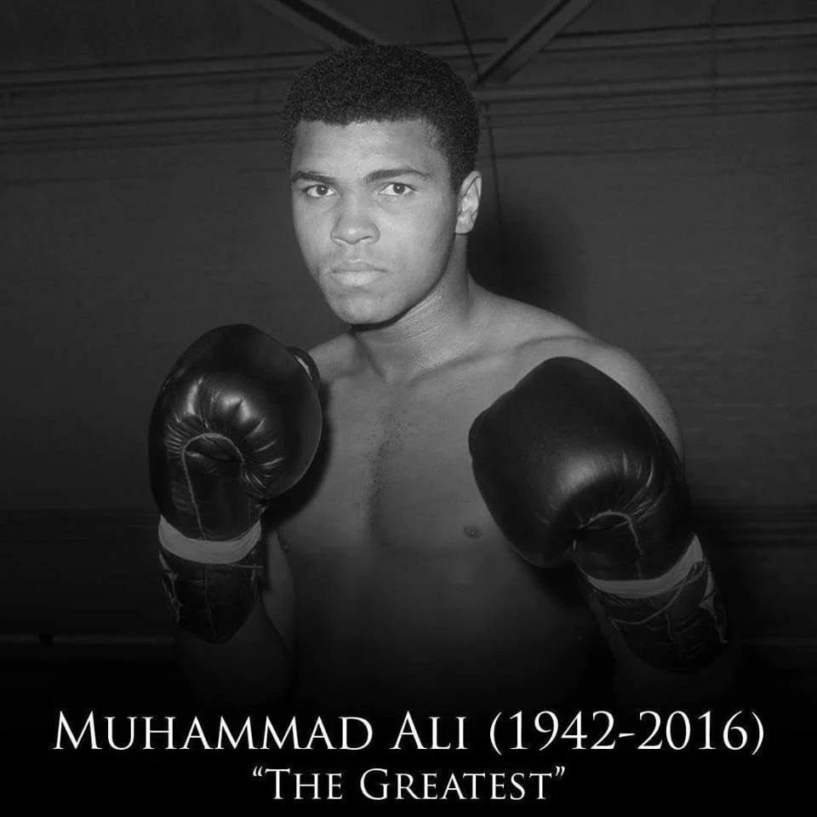
May you rest in peace, champ. قد ترقد في سلام بطل

References
Bieler, D. (2020). Bill Russell led an NBA boycott in 1961. Now he’s saluting others for ‘getting in good trouble’. Retrieved from https://www.washingtonpost.com/sports/2020/08/27/bill-russell-nba-boycott
Burns, K., & Burns, S. (2021). Muhammad Ali: A film by Ken Burns, Sarah Burns & David McMahon. Season 1, Episode 3: Round Three: The Rivalry (1970-1974). [DVR]. Public Broadcasting Service.
Hackman, M. Z., & Johnson, C. E. (2013). Leadership: A communication perspective. Long Grove, IL: Waveland Press, Inc.
History.com. This Day in history | April 15. Retrieved from https://history.com/this-day-in-history/jackie-robinson-breaks-color-barrier
The Holy Bible: New King James Version. (1988). Nashville, TN: Thomas Nelson Publishers.
Maher, A. (2016). Here’s why Muhammad Ali refused to serve in the US army. Retrieved from https://adigitalboom.com/why-muhammad-ali-refused-to-serve-in-the-us-army/
Michael. (2016). Muhammad Ali leadership profile. Retrieved from https://www.leadershipgeeks.com/muhammad-ali-leadership/
Morgan, E. (2016). Muhammad Ali’s religion: 5 fast facts you need to know. Retrieved from https://heavy.com/sports/2016/06/muhammad-ali-religion-muslim-nation-of-islam-sufism-vietnam-war-malcolm-x-donald-trump/
Quinn, B. (2018). Lew Alcindor, Michigan, and the mystery of the big what-if? Retrieved from https://theathletic.com/178136/2017/12/08/lew-alcindor-michigan-and-the-big-what-if/
Sullivan, E. (2018). Laura Ingraham told LeBron James to shut up and dribble; he went to the hoop. Retrieved from https://www.npr.org/sections/thetwo-way/2018/02/19/587097707/laura-ingraham-told-lebron-james-to-shutup-and-dribble-he-went-to-the-hoop
Tony. (2018). Muhammad Ali’s leadership qualities and what we can learn from them. Retrieved from https://www.anthonygregg.com/insights/leadership-lessons-you-can-learn-from-muhammad-ali/#:~:text=Muhammad%20Ali’s%20leadership%20qualities%20and%20what%20we%20can,4%20Promote%20resilience%20rather%20than%20punishing%20failure.%20

